**IUP Lec 3**

**Image Enhancement**

This will enable to enhance certain features in the image so that the result is more suitable than the original image for specific condition

Ex:

* if the noise is there need to use a noise filter
* If the image is dark need to use the contrast enhancement technique

These techniques are problem oriented

Ex

The technique for x ray images may not be suitable for microscope images

Enhancement technique fall under two categories

spatial domain technique

Frequency domain technique

|  |  |
| --- | --- |
| **spatial domain technique** | **Frequency domain technique** |
| Direct manipulation of the pixels. | No direct manipulating instead modifies core values |
| Works on the. Image plane |  |

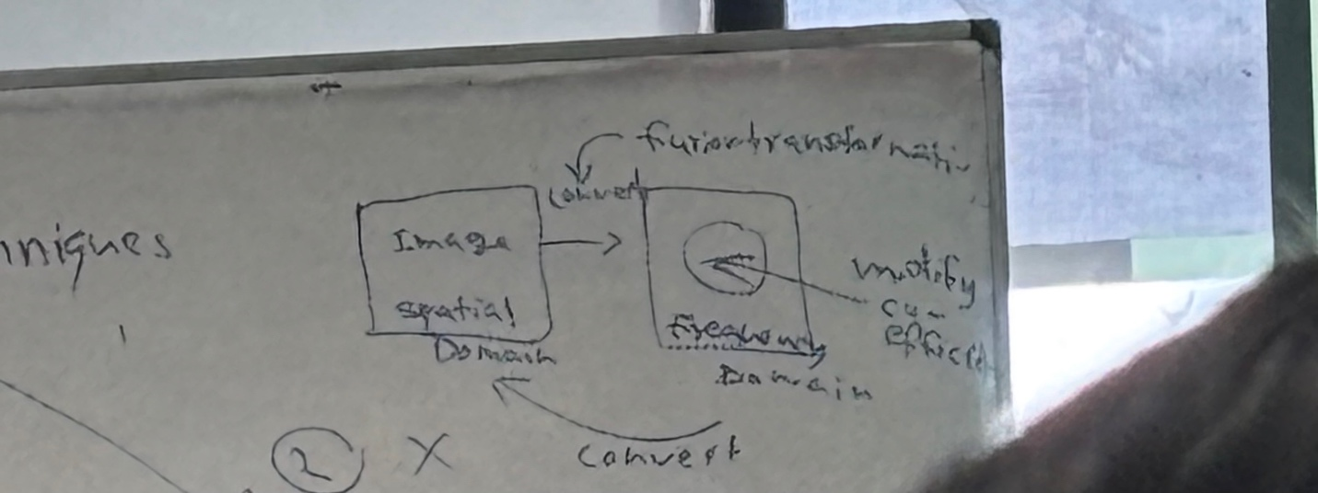

**Insensitive transformation [T]**

After applying the transformation function for the input image we can get the output image

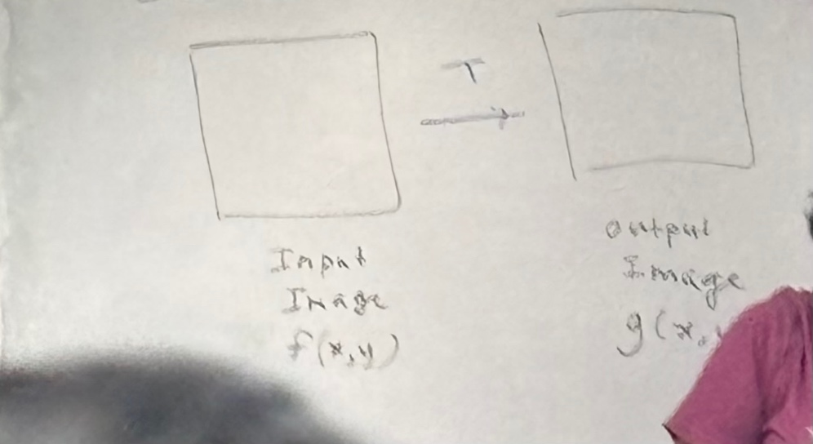

We track the location using (x,y) and if we apply a change to the relevant x,y it will automatically apply for the output image’s same location . we change single point at a time

As a example if we apply for the (x1,y1) location and the output will be converted and it will apply the change to the output’s (x1,y1) location.

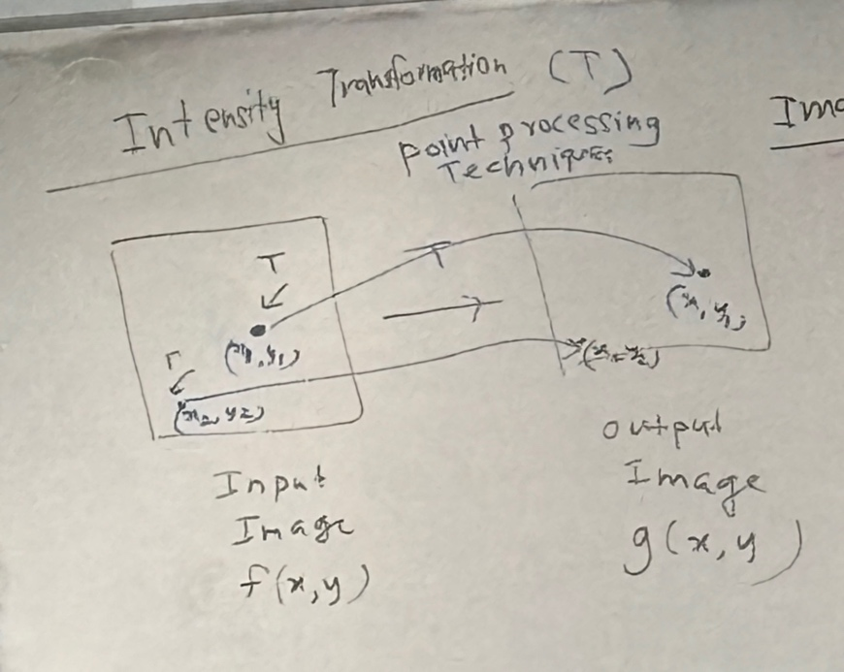

**Transformation function types**

1. Identity Transformation

No changes on the intensity values input and output values will be the same

The graph is like y=mx

S = T(r)

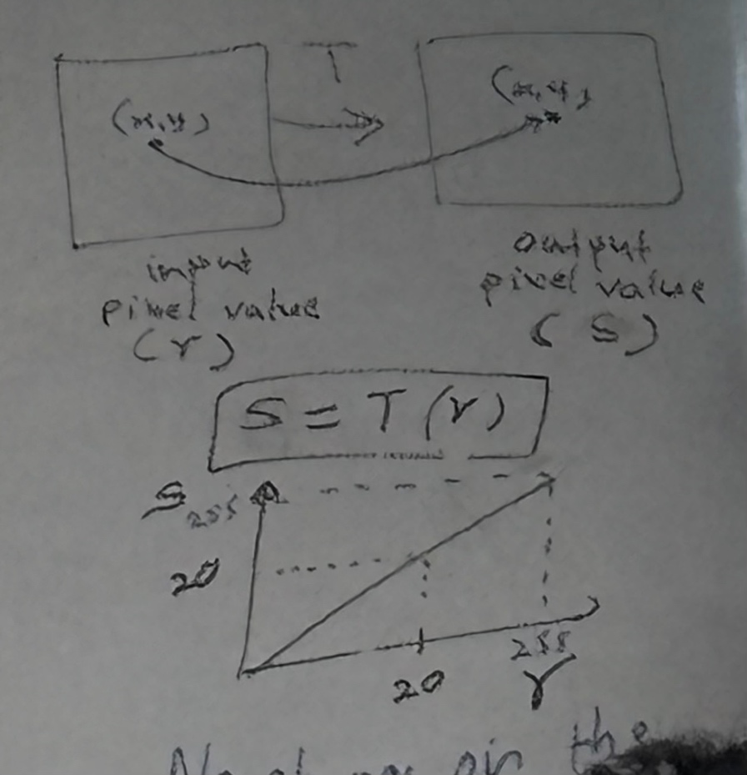

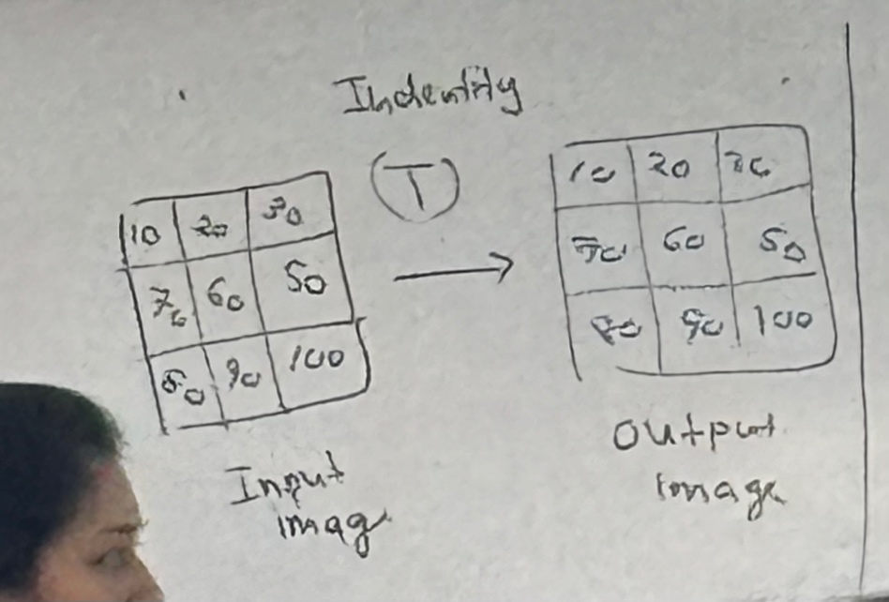

**2. Threshold Transformation**

we determine the r value according to the given threshold value (m)

if m is greater than or equal to r the s is 0 . if the m is less than r the s value is 255

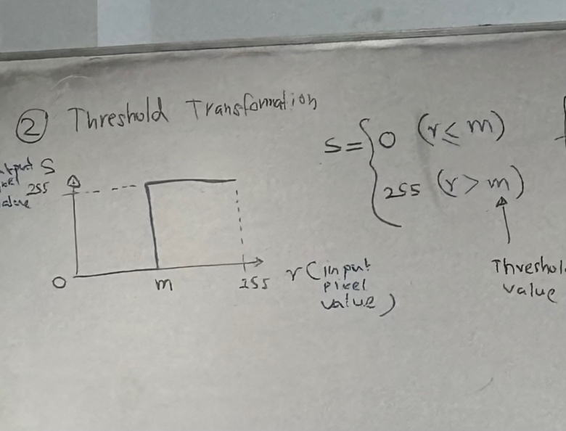

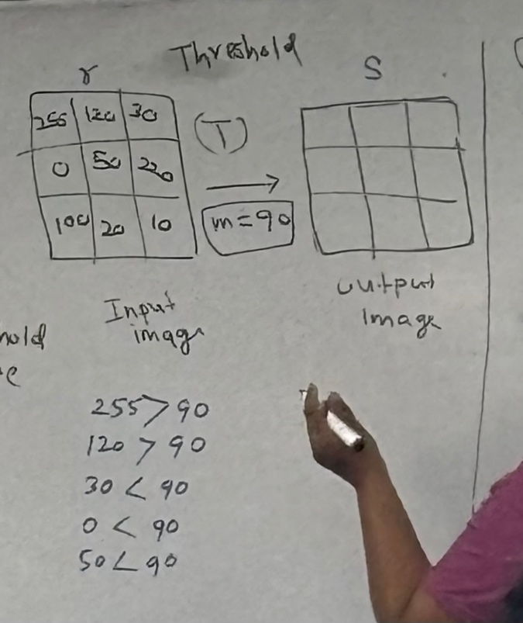

So finally we get a binary (black and white) image

**3. Negative Transformation**

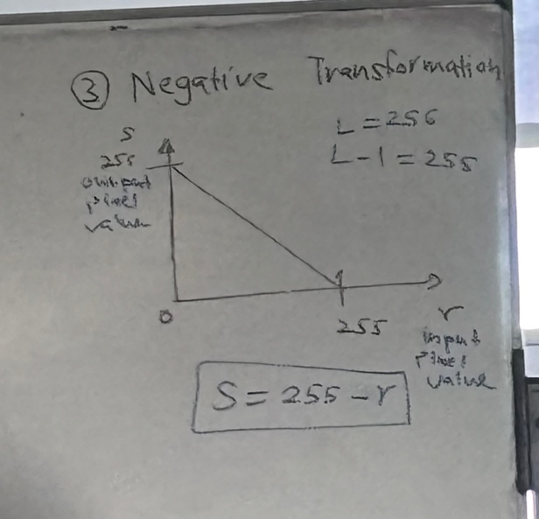

If r = 255, s = 0

If r = 240, s = 15

If r = 230, s = 25

If the intensity values are high, after converting they will be low intensity

If r = 0, s = 255

If r = 20, = 235

If r = 30, = 225

If the intensity values are low, after converting they will be high intensity

This one is most popular in medical images.

**4. Contrast stretching**

**(video – 1.39)**

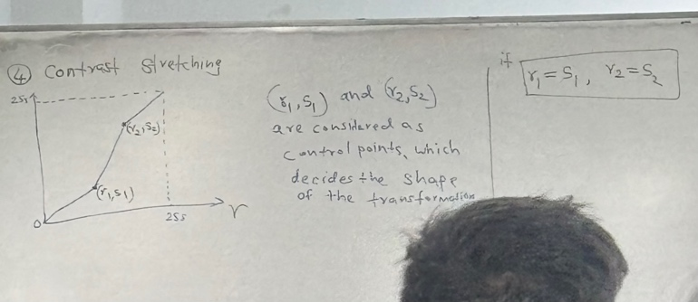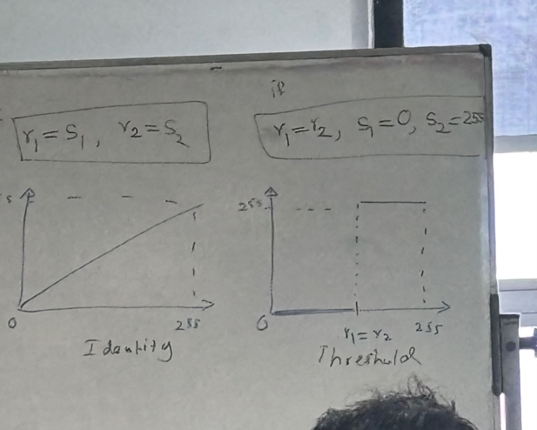

Q - For image with intensity range [50-150] what should (r1, r2) be to increase the dynamic range of the image to [0-255]

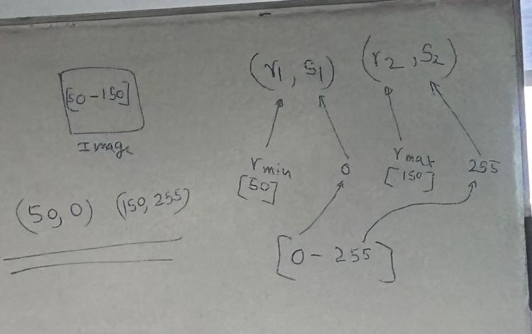

**5. Log Transformation**

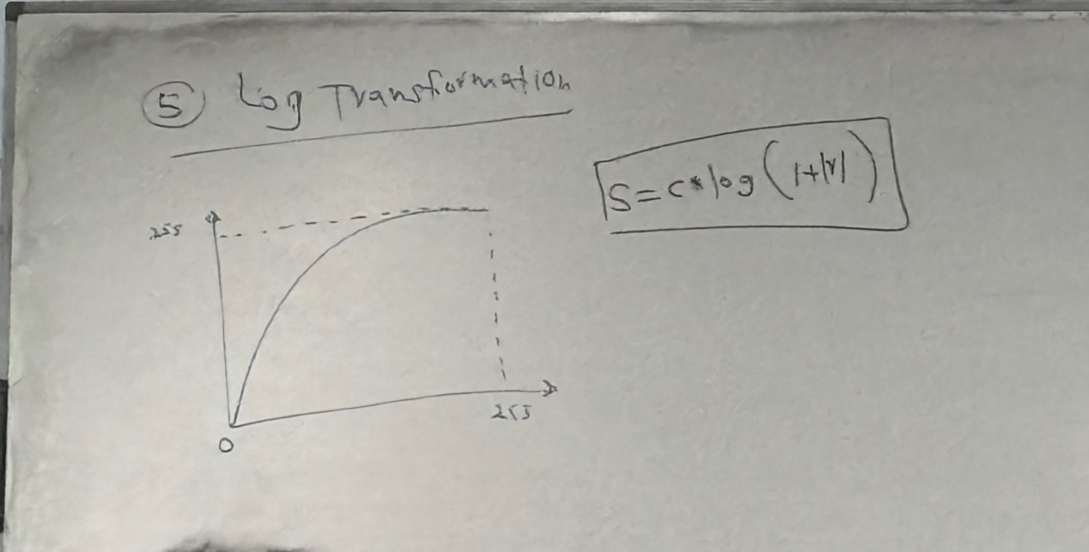

S = c log (1+|r|) c is a constant

Lower intensities will be expanded, intensities will be mapped as a form of expand. (values near 0)

Higher intensities will be mapped a s a form of compressing (values near 255)

True bright will be reduced and the dark details will be not too dark

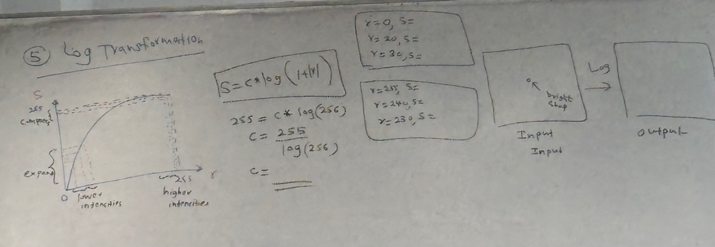

R = 0, S = c log (1+0) = 1

R = 20, s = 140

R = 30, s = 158

Dark details will be brighter

R = 255, s =

R = 240, s =

Bright won’t be too dark.

**6. power – low (gamma) transformation**

We need to consider the gamma value as well. If gamma is greater than 1 it’s a dark image . otherwise to obtain bright image gamma must be less than 1.

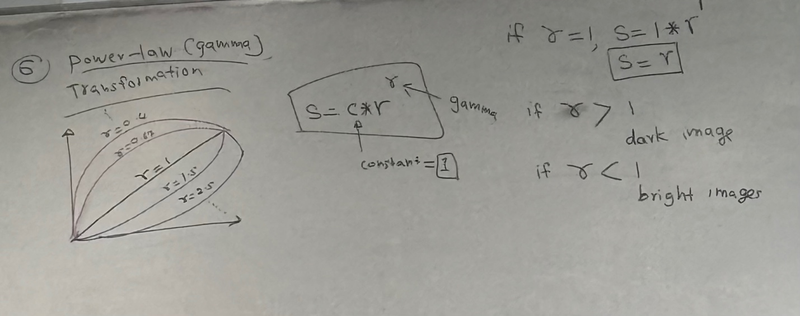

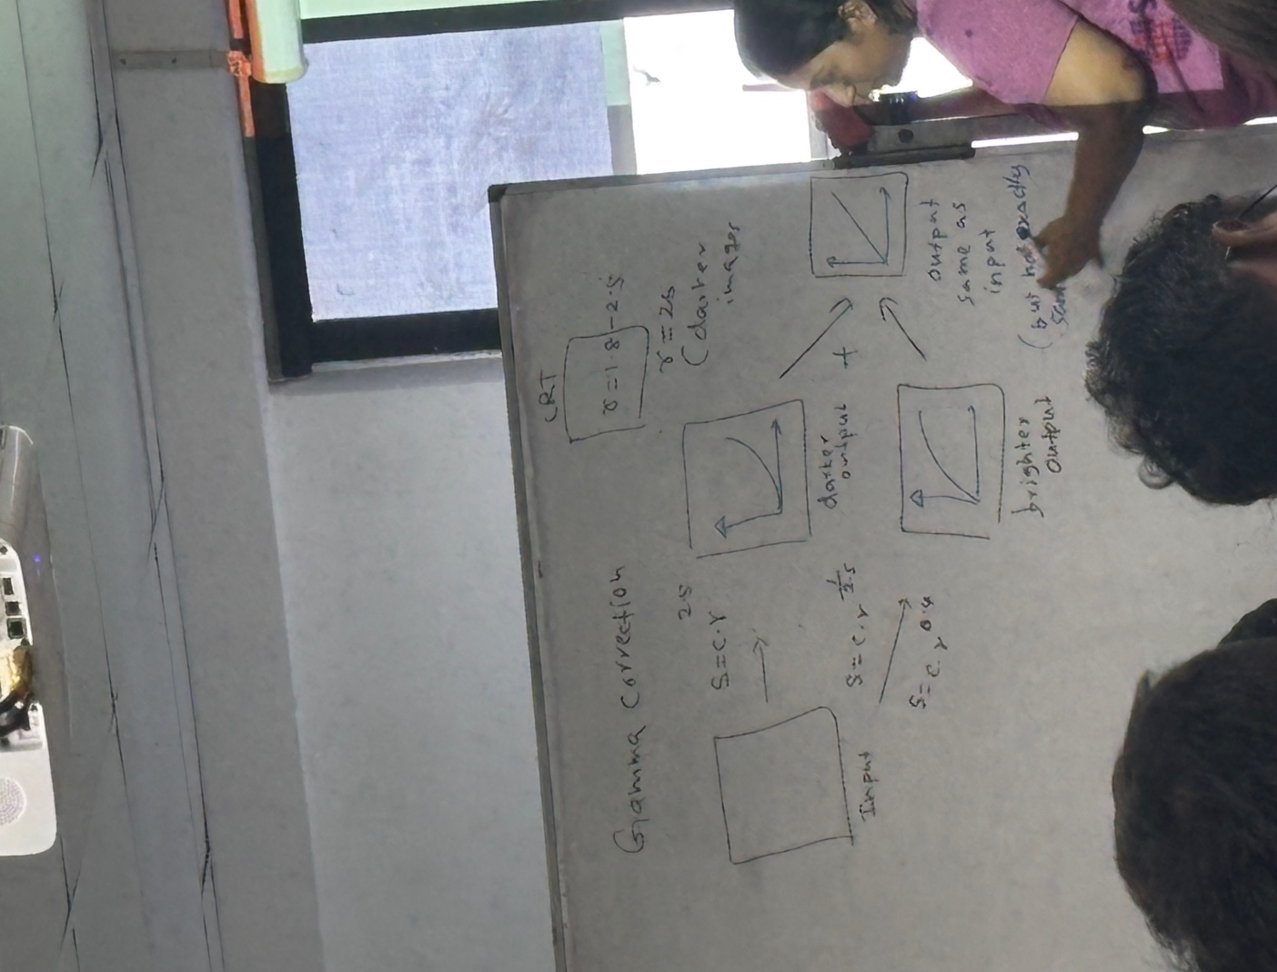

To get more brighter image we combine dark and the light output .

**7. Gray – level slicing**

Used to highlight specific range of intensity value (area of intereset)

